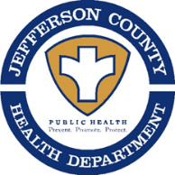
RABIES ALERT!
Public Notice From:
Jefferson County Health Department (WV)
1948 Wiltshire Road
Kearneysville, WV 25430
(304) 728-8416 – Extension 3037

This is a public health notification that the
Jefferson County (WV) Health Department has issued a
“Rabies Alert” for the
Potomac Terrace Drive area of
Harpers Ferry

The WV Office of Laboratory Services notified our office (JCHD) on December 22, 2022 of a “POSITIVE” test result for the rabies virus from a – RACCOON– submitted by us, from the above area.

Description: RACCOON
If you believe that you or someone else, had contact with this animal, please call the Jefferson County Health Department at (304) 728-8416 ext. 3037

All Citizens are also being reminded to make sure your animals are currently vaccinated against rabies and to avoid contact with wildlife!
Do not Feed or Approach Wildlife, including feral cats.

