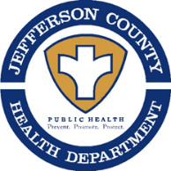
RABIES ALERT!
Public Notice From:
Jefferson County Health Department (WV)
1948 Wiltshire Road
Kearneysville, WV 25430
(304) 728-8416 – Extension 3037

This is a public health notification that the
Jefferson County (WV) Health Department has issued a
“Rabies Alert” for the
Grayrock Road area of
Charles Town

Our office (JCHD) was notified on December 20, 2022 of a “POSITIVE” test result for the rabies virus from a – PUPPY– submitted by Valley Emergency Vet, from the above area.

Description: 11 month old Red Pit Bull/Mix PUPPY
If you believe that you or someone else, had contact with this animal, please call the Jefferson County Health Department at (304) 728-8416 ext. 3037

All Citizens are also being reminded to make sure your animals are currently vaccinated against rabies and to avoid contact with wildlife!
Do not Feed or Approach Wildlife, including feral cats.

